***Systems Biology***

***Assignment – 2***

*-BS19B032*

*-R. Vasantha Kumar*

*From the given networks, I have chosen the bio-yeast network from biological networks.*

*When plotted the above network will look like,*

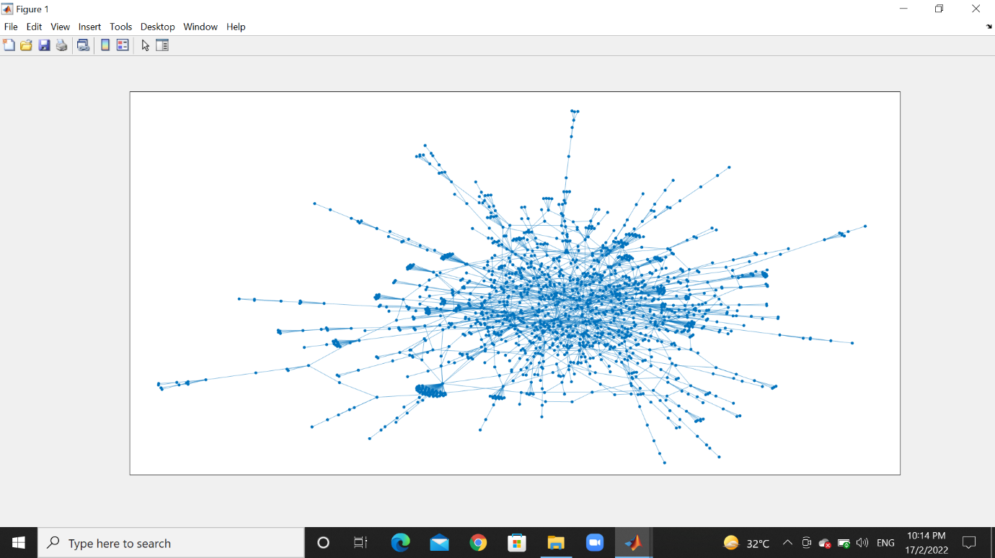

*1)Scale-free properties of the network:*

*a) This is a histogram plot of Degree Distribution N(k) vs k.*

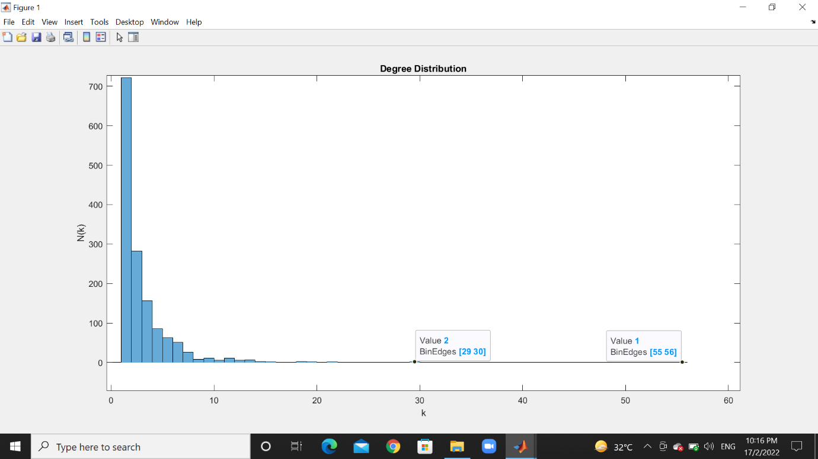

*b) This is the plot for log(N(k)) vs log(k).*

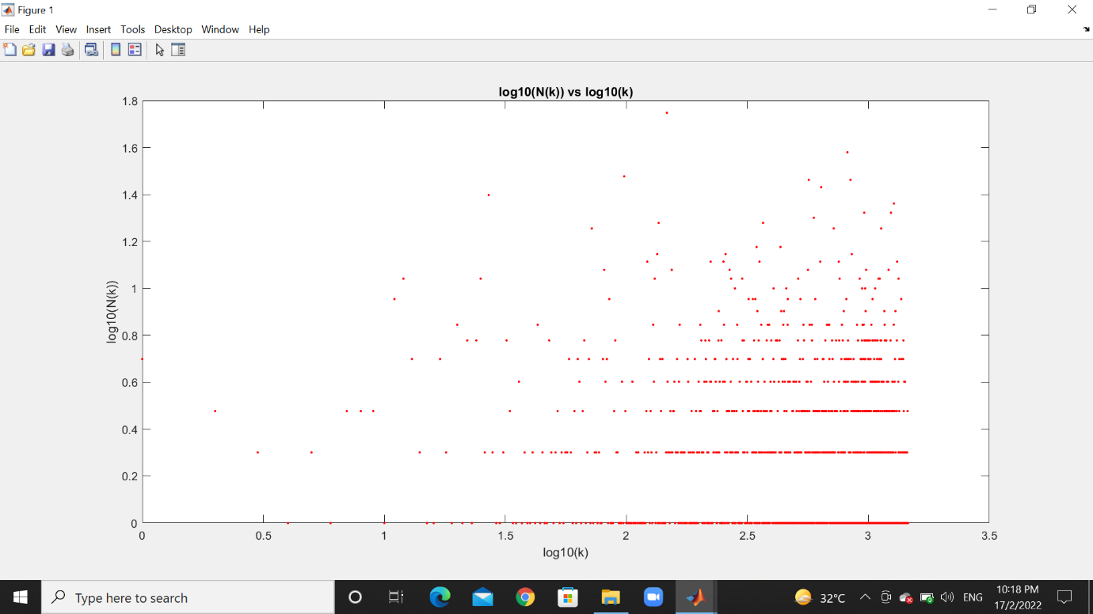

*The computed spearman correlation coefficient is 6.6089.*

*The p-value is 1.3770e+03.*

*c) After fitting a linear relationship between log(N(k)) vs log(k) and plotting it:*

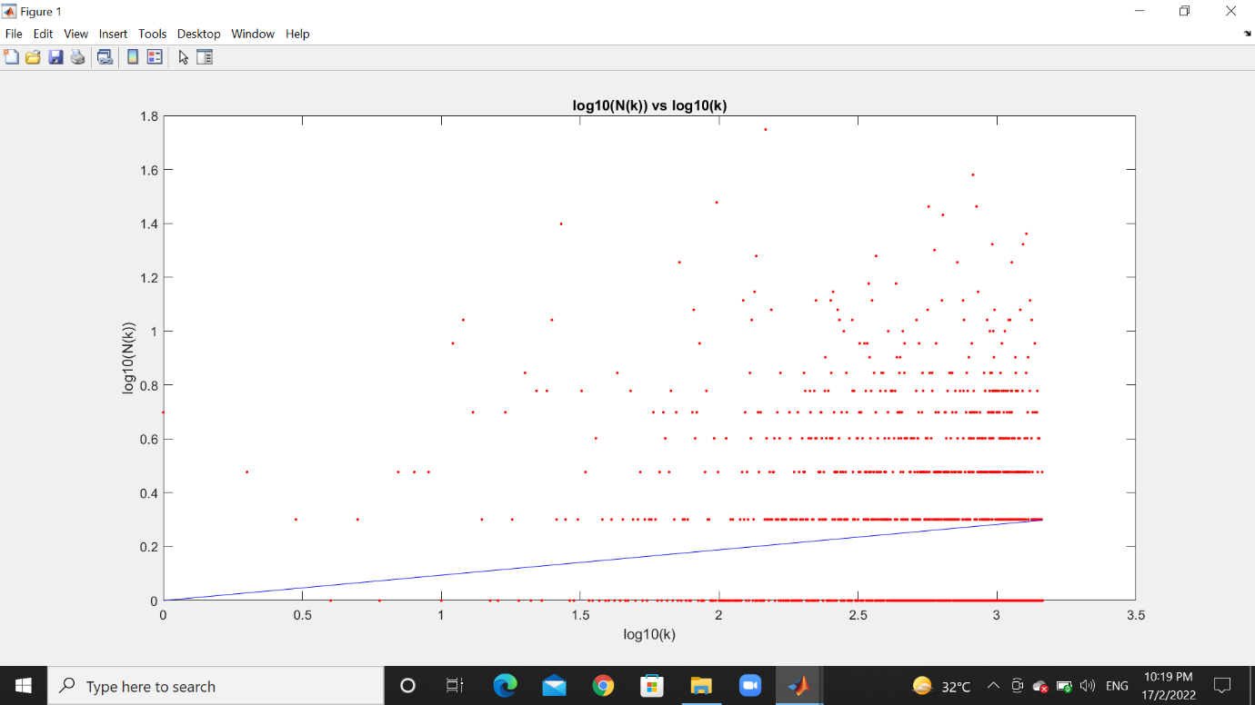

*The goodness of the fit R2 score is -0.052966.*

*The slope of the line is 0.0942.*

*d) My network structure is slightly spherical with many inter-connected nodes. Maximum degree of a node is 56 and minimum degree is 1. The average degree of the network is 2.*

*This network does not follow the power law. As we could see in the log(N(k)) vs log(k) graph the scattered points doesn’t tend to form a straight line. Even while given the linear fit, the negative R2 score shows that it is a bad fit.*

*2)* *Small world properties of the network:*

*a) The computed average shortest path length of the network (𝐿) is 6.807694.*

*The plot for distribution of all the shortest path lengths of the network is:*

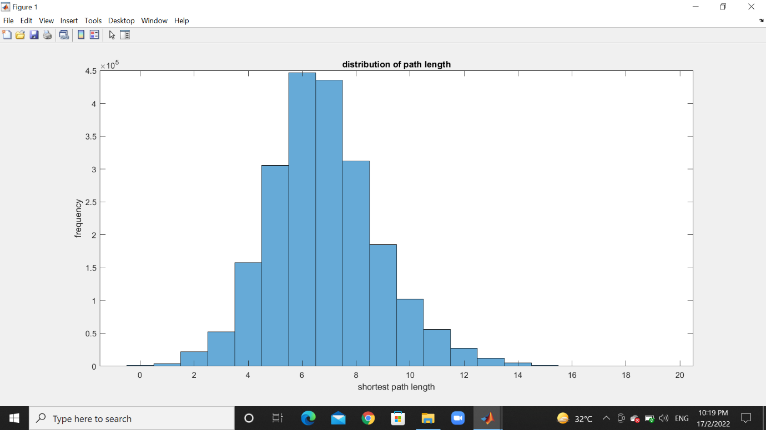

*b) Using the erdos_reyni function in the MATLAB BGL, I generated 1000 Erdos-Renyi networks with same number of nodes and edges. Then computed the average shortest path length of all these networks. Then finding the mean of all, I get mean average shortest path length[Lr] - 1.2591.*

*c) Plotting the clustering coefficient distribution C(k) vs k:*

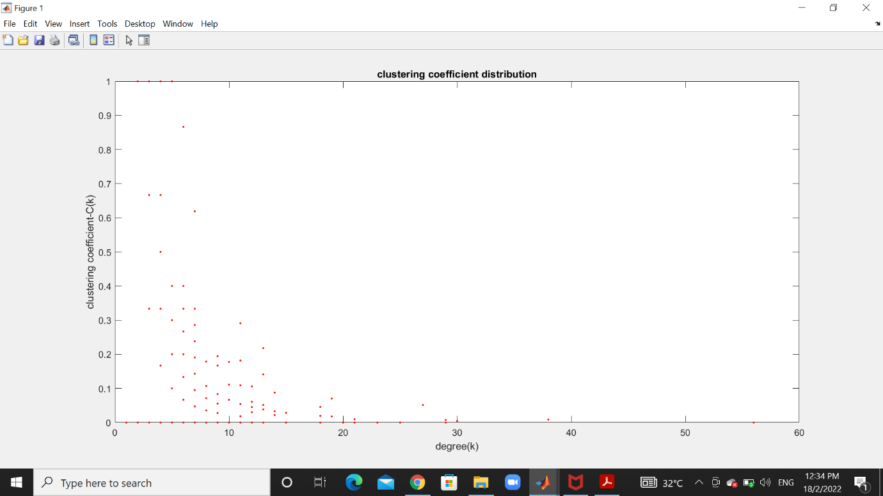

*Now, computing the average clustering coefficient of the network (C) = 0.070830.*

*d) Using the formula,*

*no. of edges = no. of nodes*K/2*

*I calculated the avg_k of the network – 2.67.*

*Then, using the table in the given paper, I found the CL = 0.19.*

*e) Using the given formula in question, I calculated the small worldness(omega) = -0.1878.*

*f) I got the small worldness(omega) of the chosen network to be negative, which means the network is regular and similar to lattices.*